**LAB PROJECT**

**DATABASE SYSTEM (CS-329)**

**SUBMITTED BY**

**MUNIB-UL-HASSAN CS19-037**

**MAAZ MOINDUDDIN CS19-042**

**ASJAD HUSSAIN RIZVI CS19-005**

**NAMIRA CS19-018**



**SUBMITTED TO**

**SIR ANAD**

**DEPARTMENT OF COMPUTER SCIENCE**

**SIR SYED UNIVERSITY OF ENGINEERING AND TECHNIOLOGY**

**SIGNUP AS ADMIN**

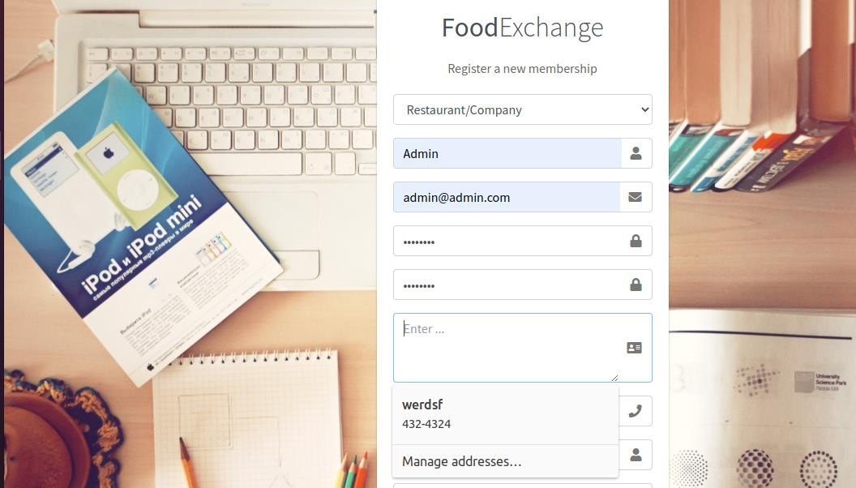

**IN DATABASE**

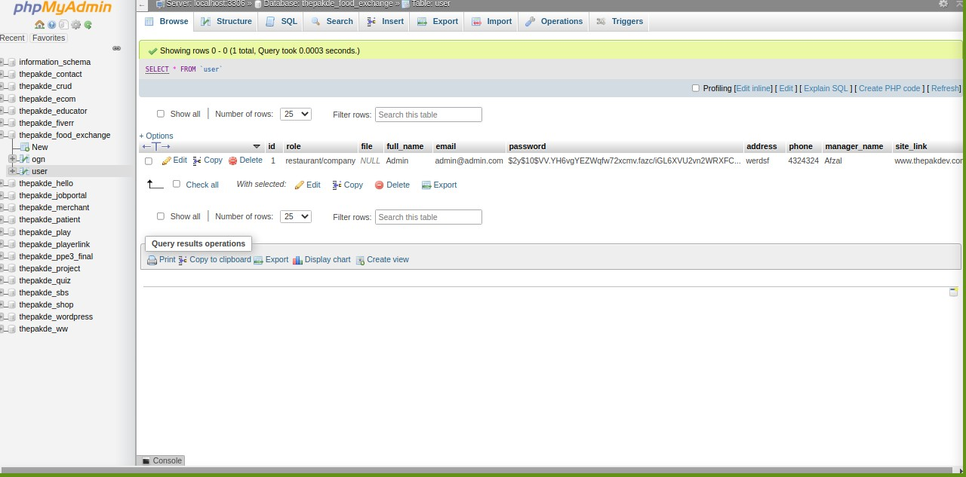

**SIGNUP AS USER**

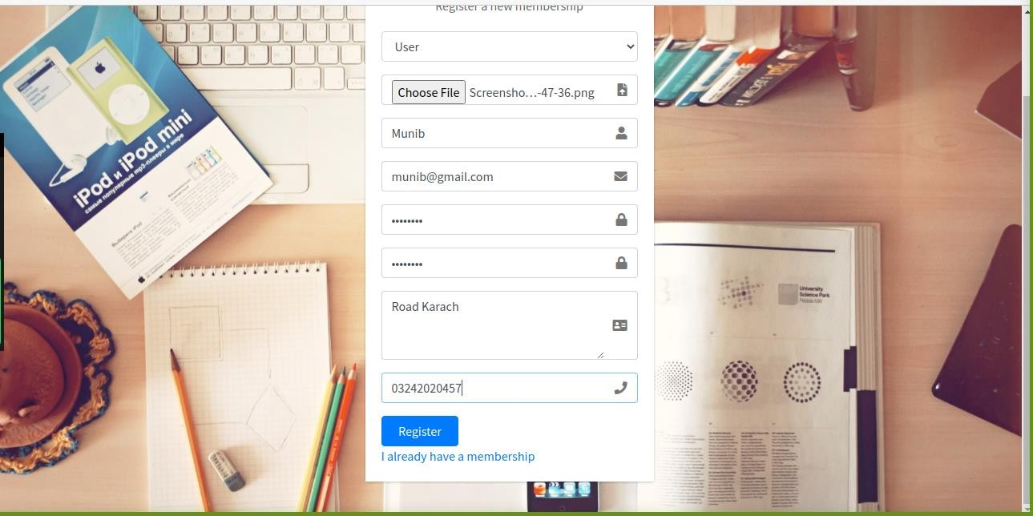

**SIGUNUP SUCCESSFULL**



**LOGIN AS USER**



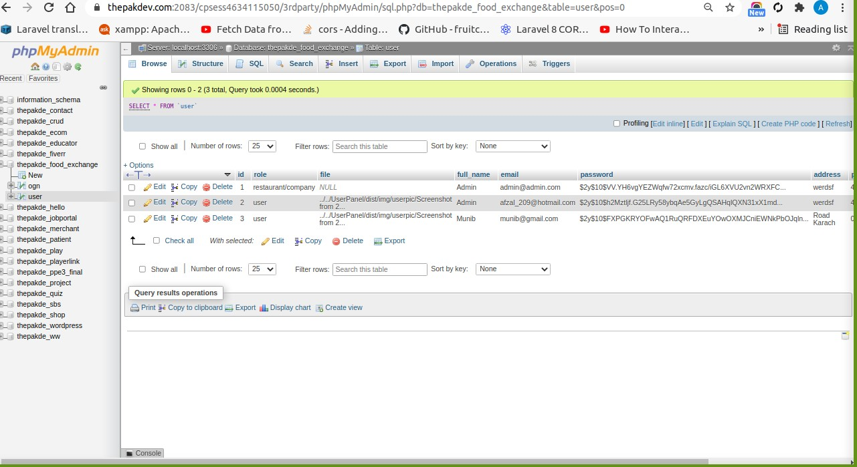

**DASHBOARD**

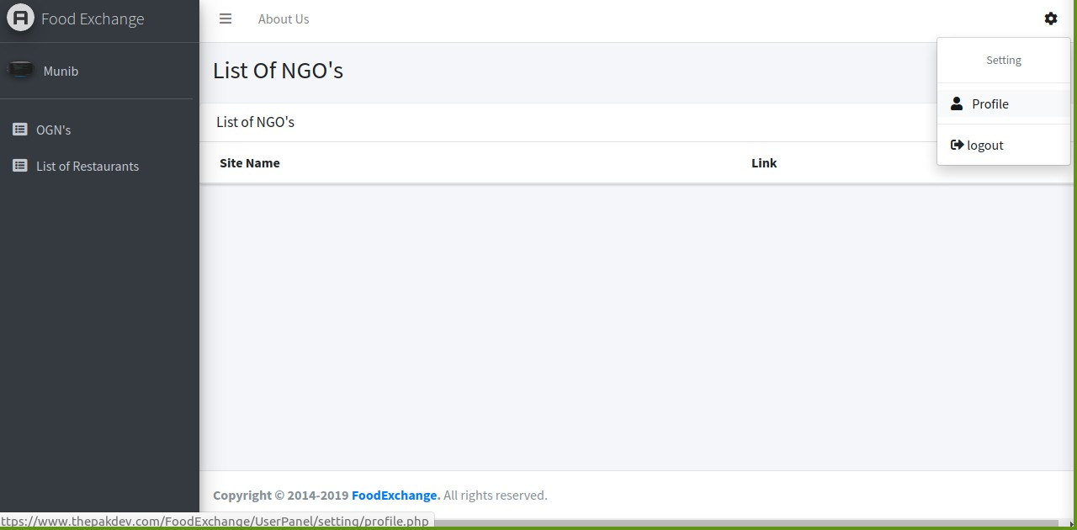

**PROFILE BEFORE UPDATE**

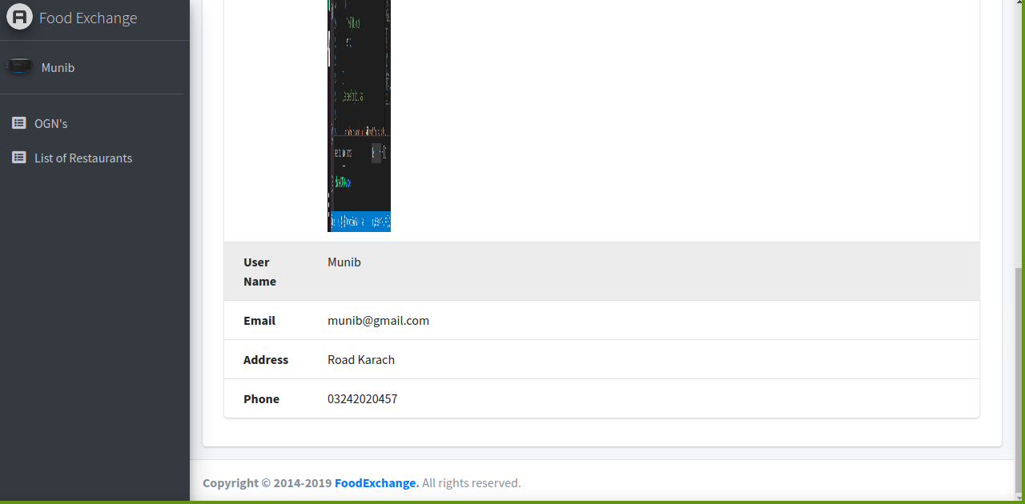

PROFILE UPDATING

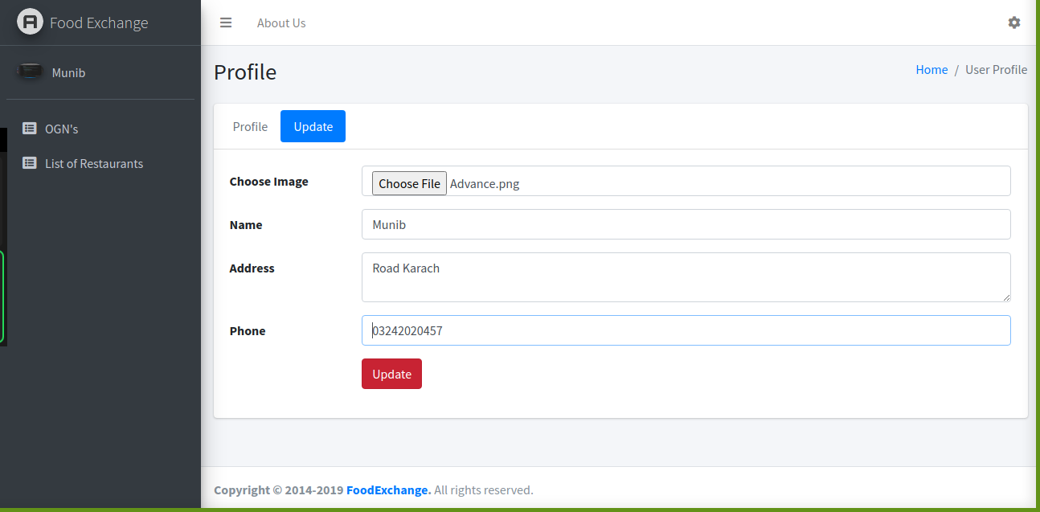

PROFILE AFTER UPDATING

